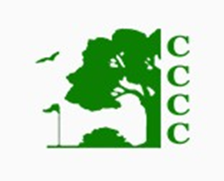

**2025 Dining Membership Renewal**

**Thanks for dining with us in 2024!**

This membership allows you to dine and drink at the Clearfield Curwensville Country Club (CCCC) in accordance with PLCB regulations and the CCCC By-laws.

There are no golf or pool privileges with this membership.

This membership is non-transferrable and expires October 31, 2025.

*2024-2025 Associate Dining Membership Dues must be paid in full when application is submitted.*

Yes! I would like to re-new my dining membership.

Single Associate Dining - $100

Family Associate Dining - $150

Dining Members

Print Name Signature

Print Name Signature

Please let us know if you have any changes:

Address:

Phone Number:

Email Address: